Installation Manual

Software needed:

The following software was used for the realization of this program:

* Xampp, which provides us with the necessary software to develop the application.

For the manipulation of the code a code editor must be used such as the following:

* Notepad++, Sublime text, Visual studio code, etc. (The one of your preference).

1. Inside our folder of xampp, we create the folder of the project as in the following route C:\xampp\htdocs\coolac
2. Inside the coolac folder we create all our project files.
3. To visualize our project, we open the xampp control panel and we start the Apache and MySql modules, and we access in our navigator to the route http://localhost/coolac/.

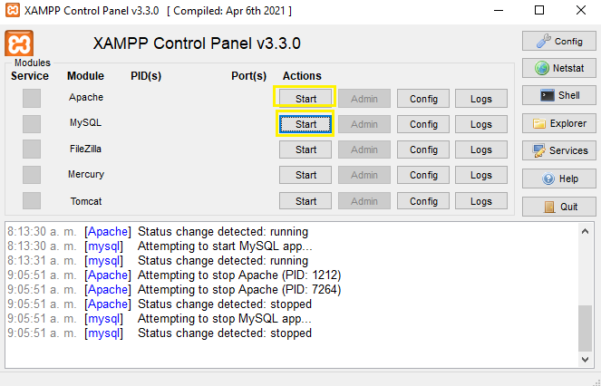

With this we have already started the Apache and MySql modules.

After clicking on start it should look like this

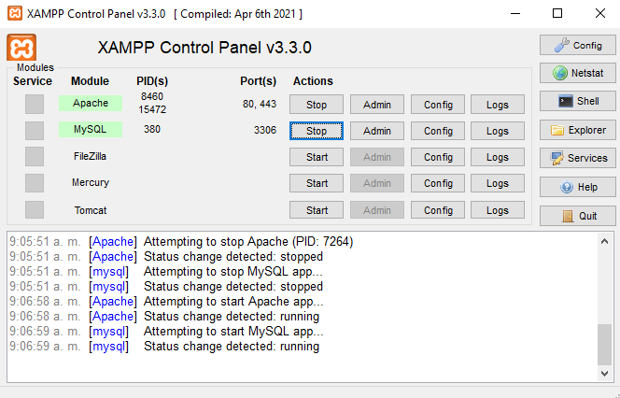

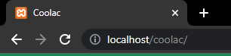

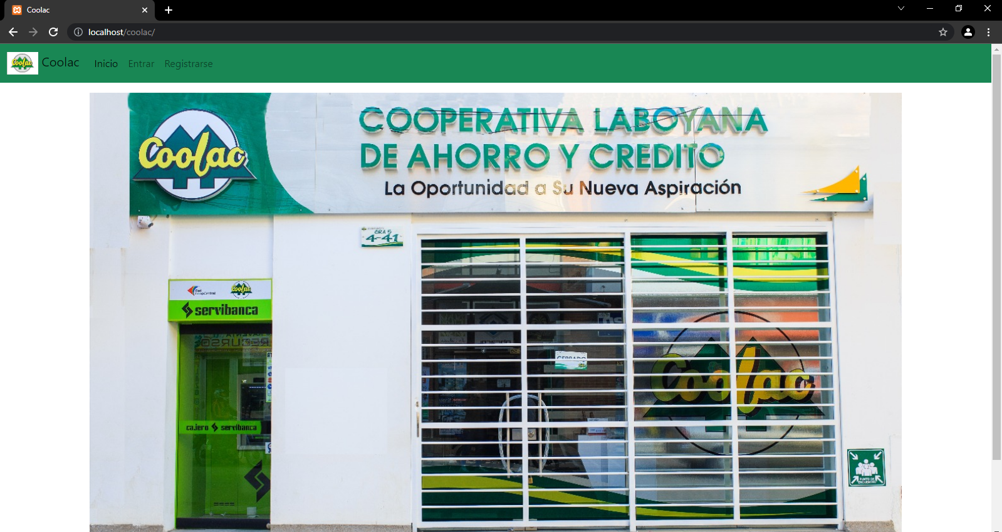

1. To create the database, we open the xampp control panel and start the services and click on Admin in the MySql module, it will open a window in the browser,

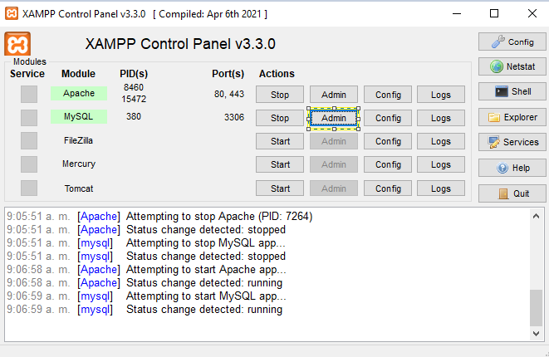

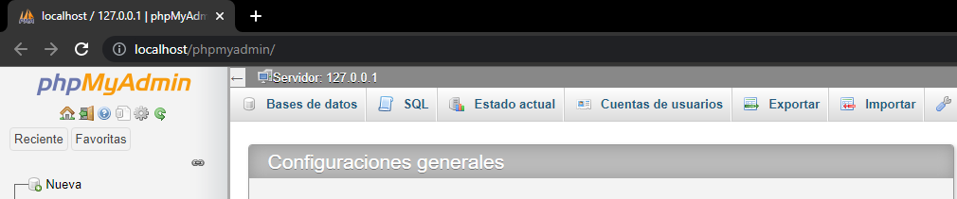

With this we have already accessed our database administrator and here we will be able to create our database and its respective tables, with one of the several ways to perform this action.

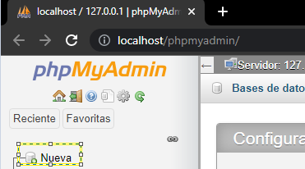

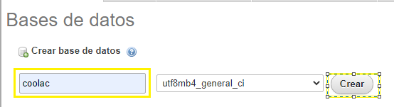

Within the coolac table, using the graphical interface we could create the tables we need

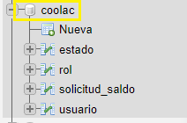

Here we would create a new table

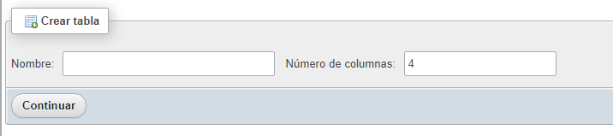

Here we would create the fields of the table

